**USER MANUAL**

**General Information**

To use the ThinCloud Mobile app, first make sure you have enough space on your Android or iOS device. Then log in to the Apple Store or Google Play according to your operating system. Then search for the name of our application and download the application to your device. Wait until the necessary installations are completed and run the application.

**Application Guide**

**1) Main Login Page**

The user must first create an account and log in to the application.

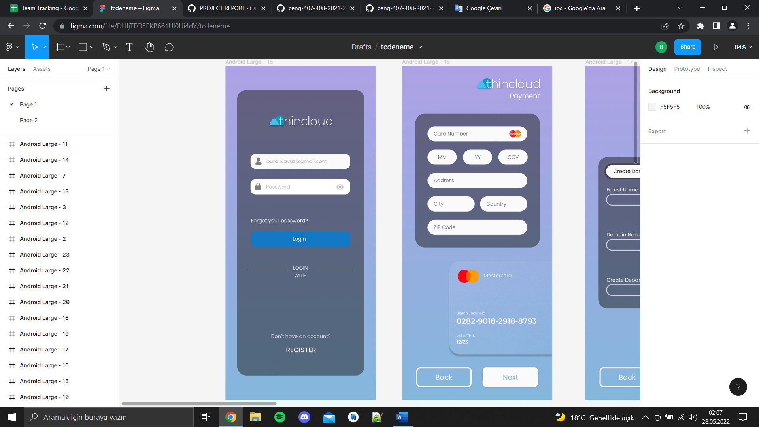

**2) Payment Page**

The user must choose a payment method to use the application. The user can access the application by entering the necessary payment information for this.

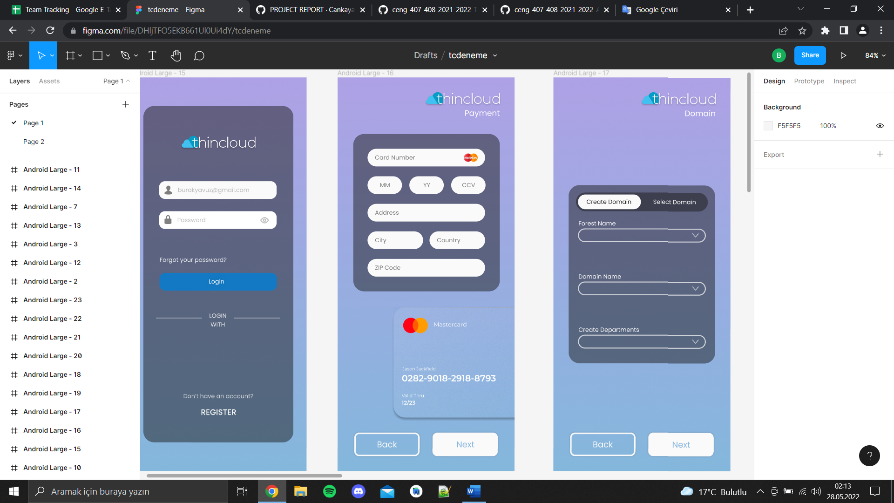

**3) Create Domain**

If the logged in user wants to create a new domain, user selects the necessary information.

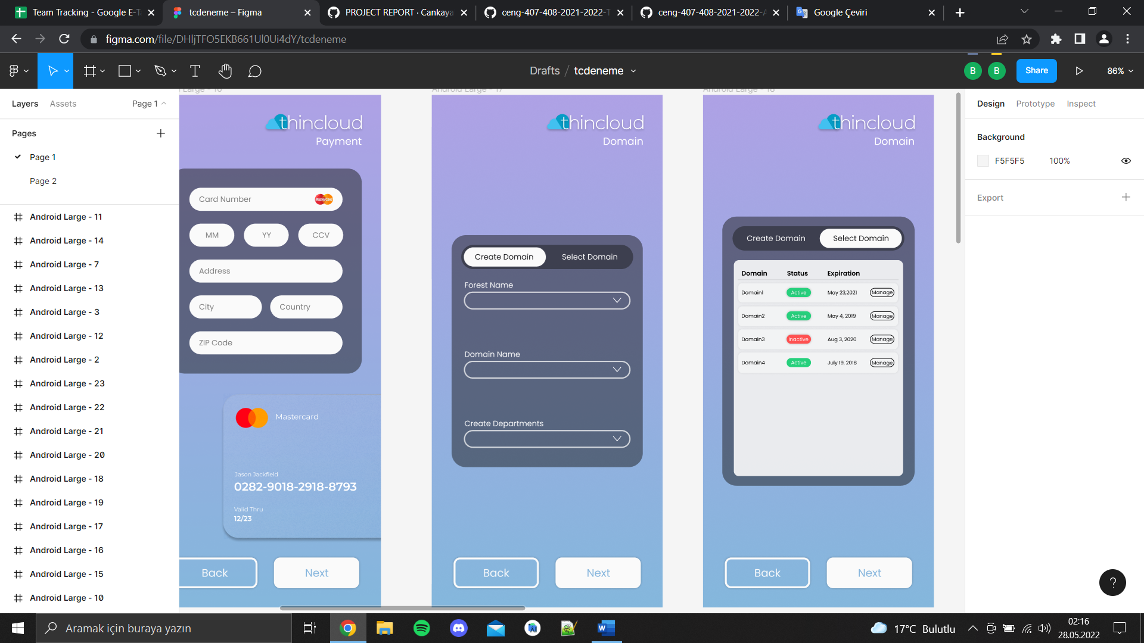

**4) Select Domain**

Login user selects a previously created domain

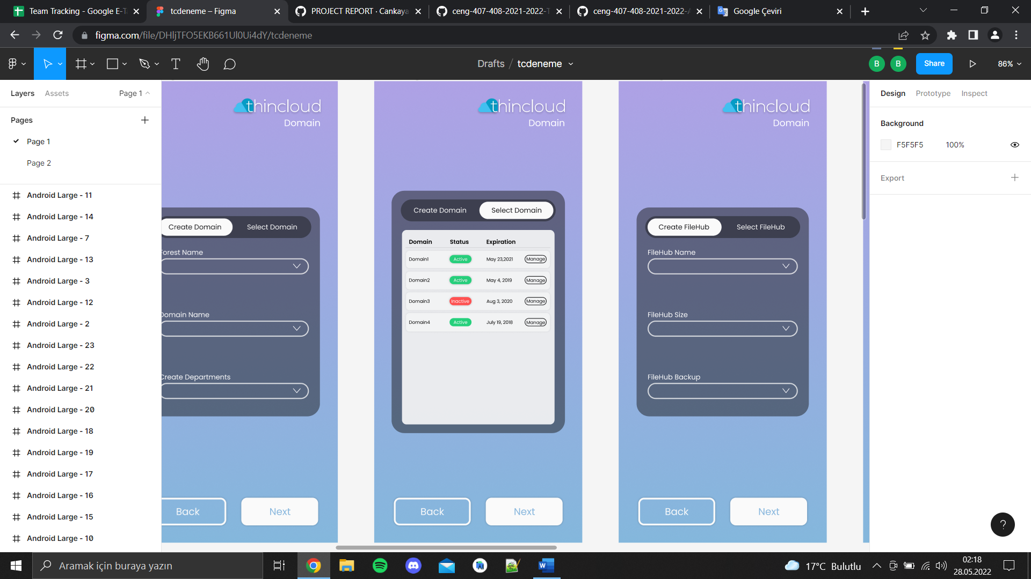

**5) Create FileHub**

If the logged in user wants to create a new filehub, user selects the necessary information.

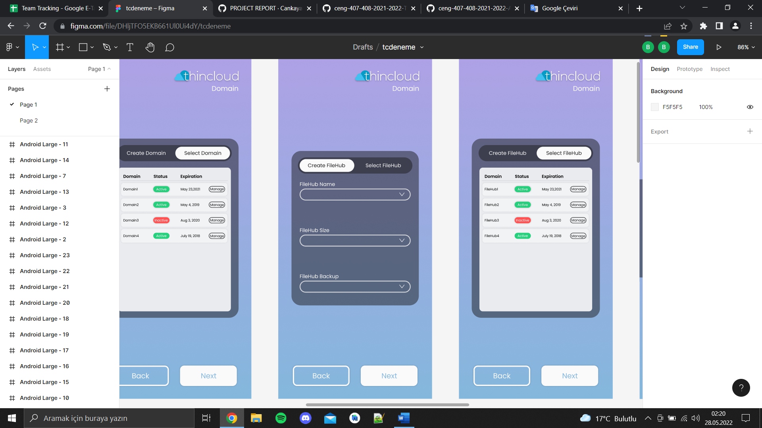

**6) Select FileHub**

Login user selects a previously created filehub.

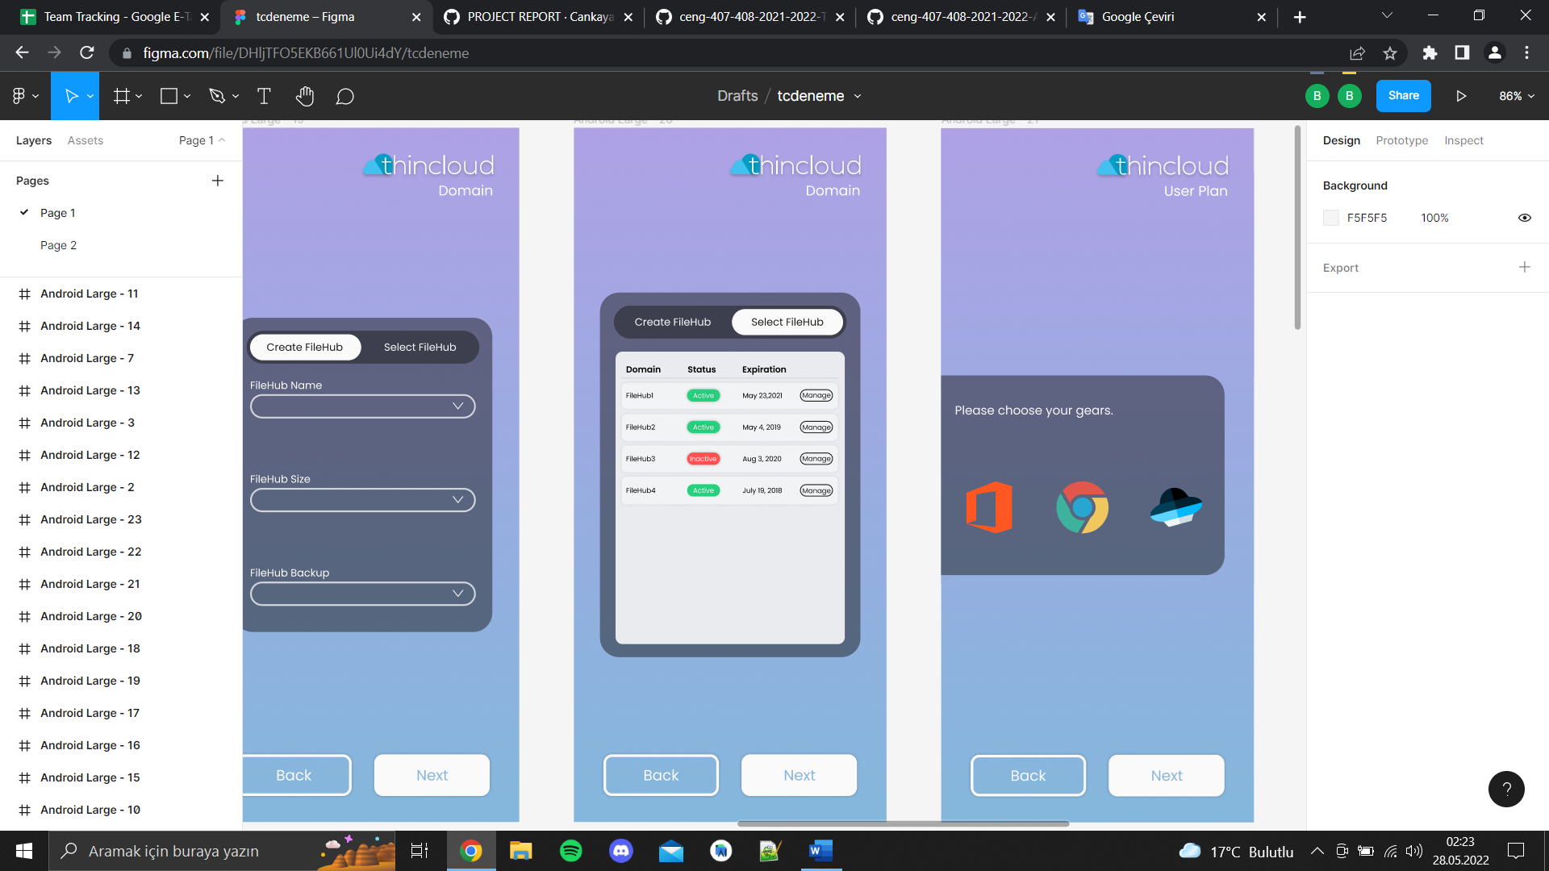

**7) User Plan**

On this page, the user must select their gears.

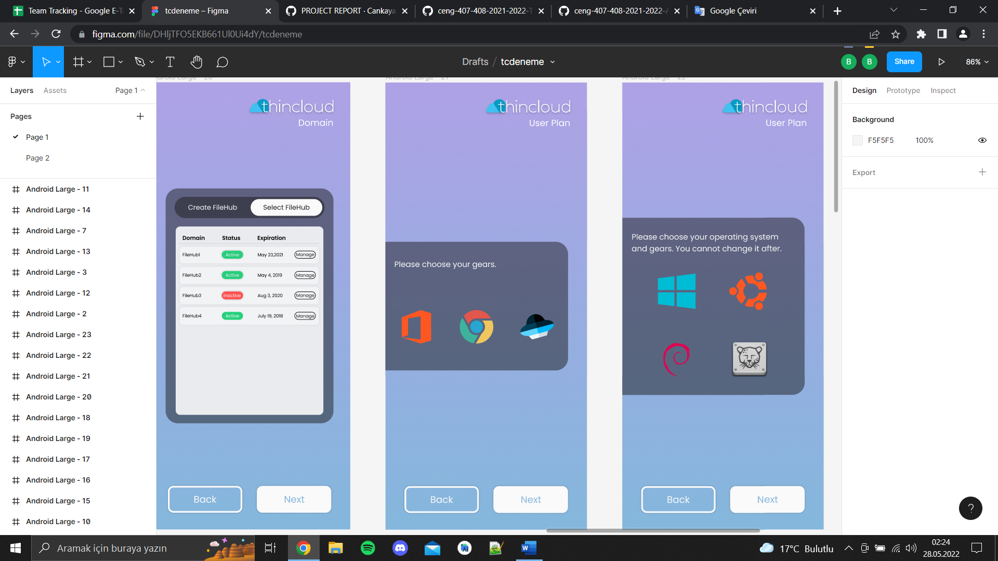

**8) User Plan Cont**

User selects OS and Gears.

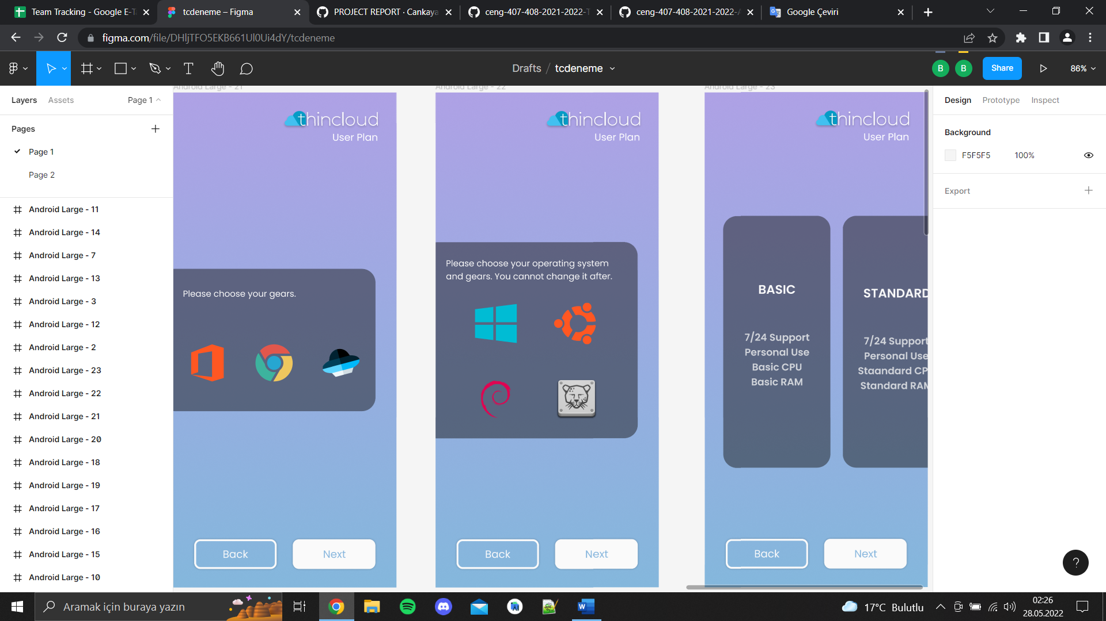

**9) User Plan Cont**

User selects package.

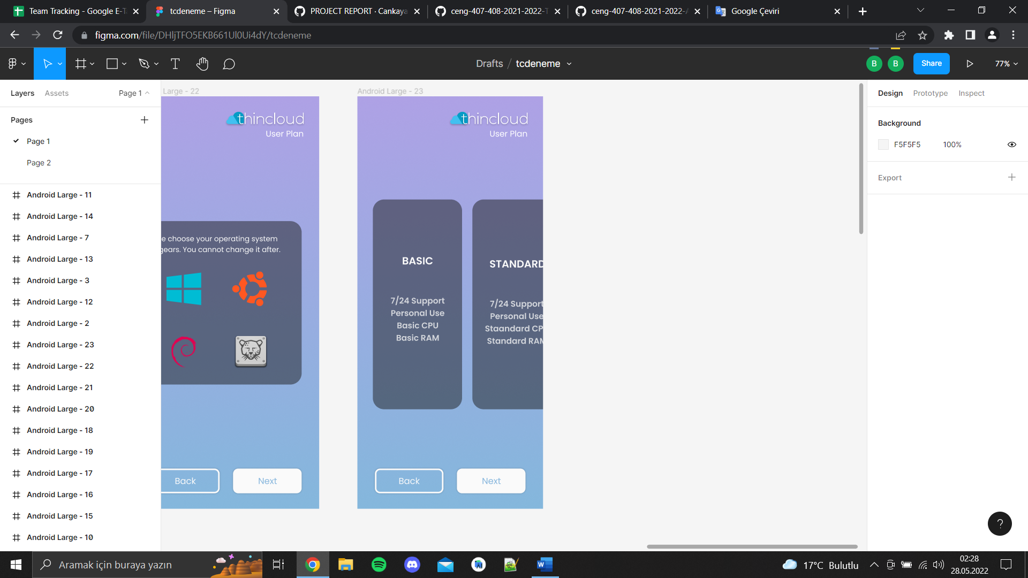

**10) Computers**

The user can view the computers user has created or add a new computer.

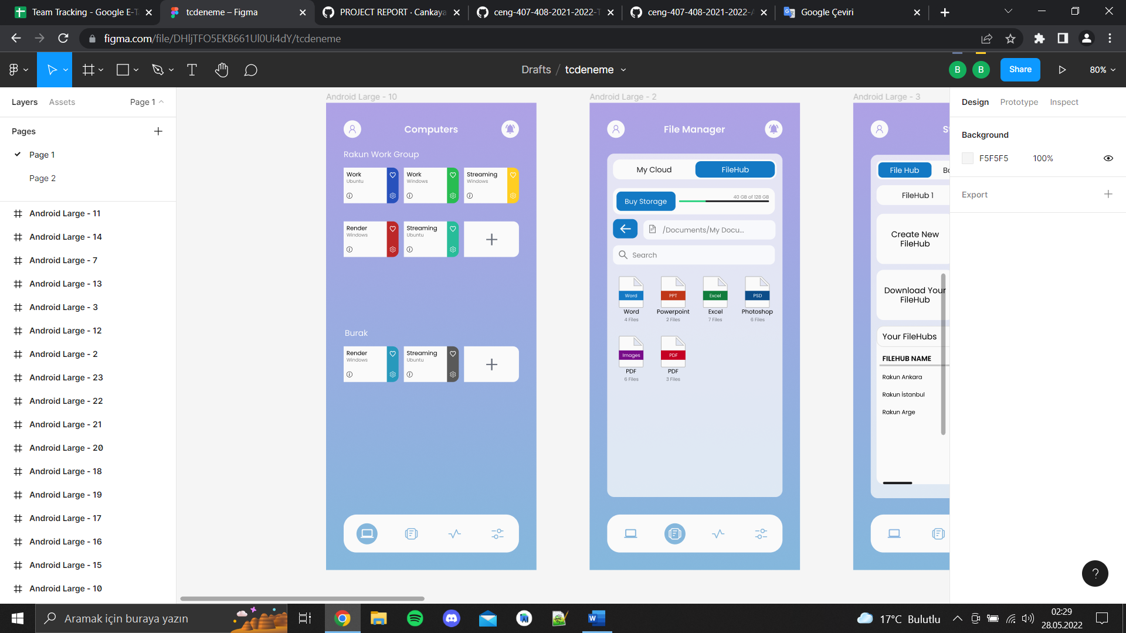

**11) File Manager**

The user views the team or their personal filehub.

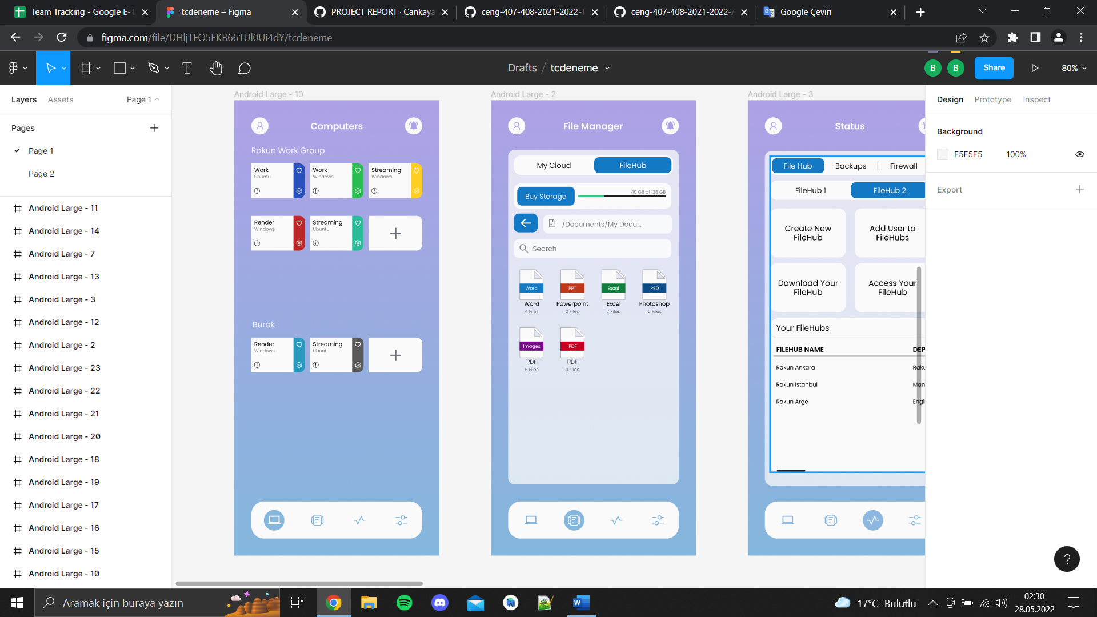

**12) Status**

**User can review the status of filehub. In addition to these, user can see the movements within the period.**

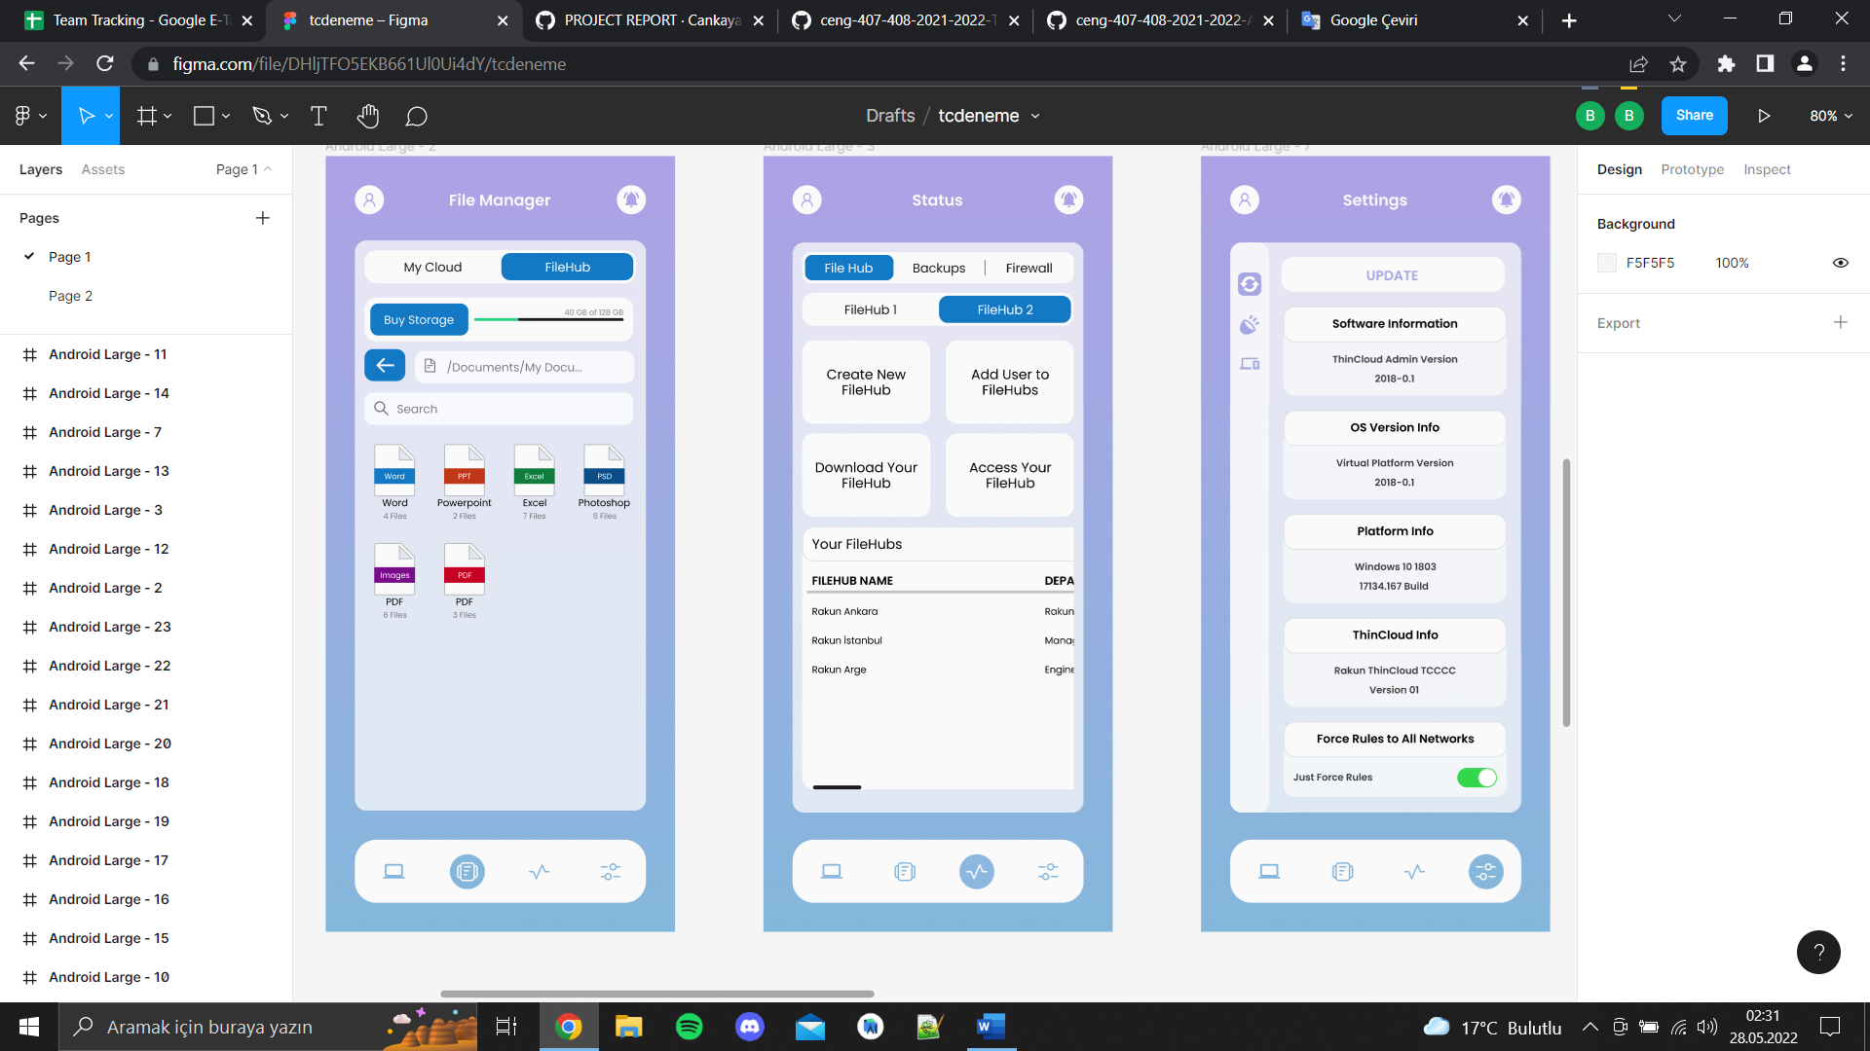

**13) Settings**

Displays a screen where the user can check for updates and interface changes.

